Programming in UML using activities
Jérémie Tatibouët, Shuai Li, Patrick Tessier and François Terrier

Lab 1 – The basics of UML activities

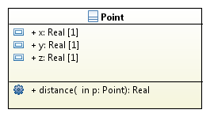

The activity below is the implementation of the “distance” operation.
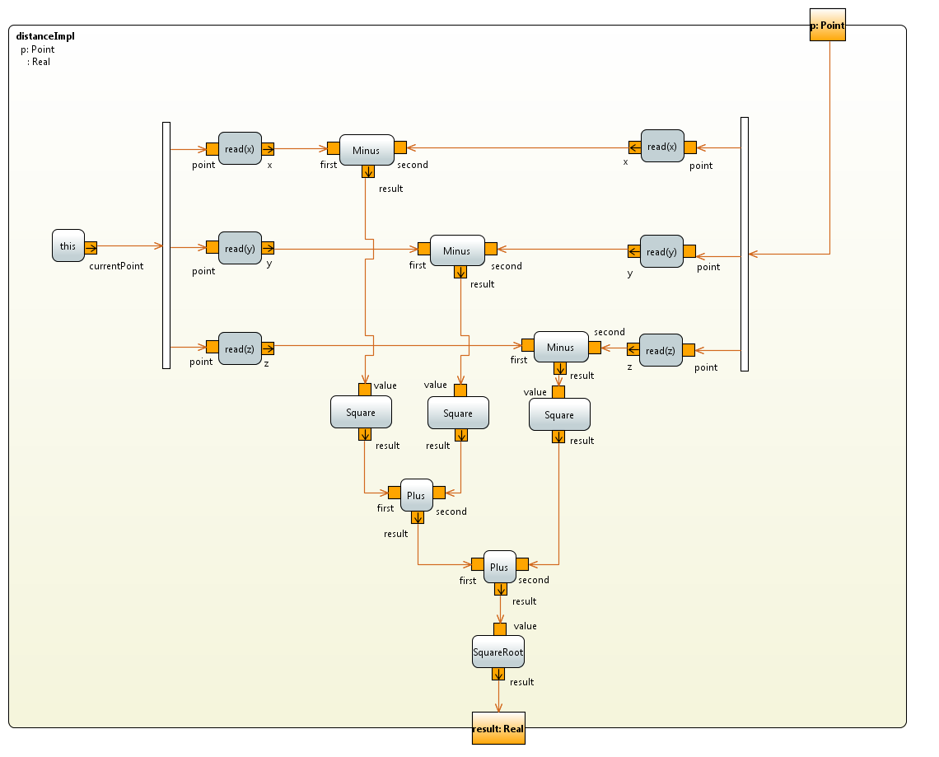

Lab 2 – Activities used in the context of communicating active objects

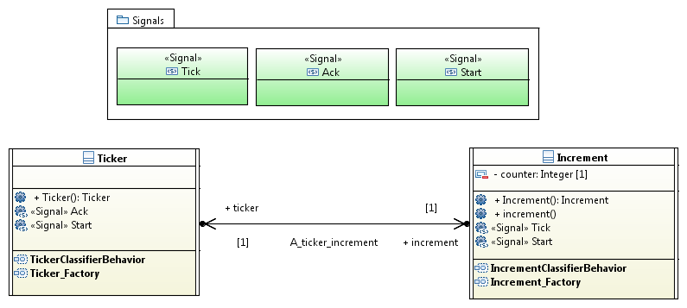
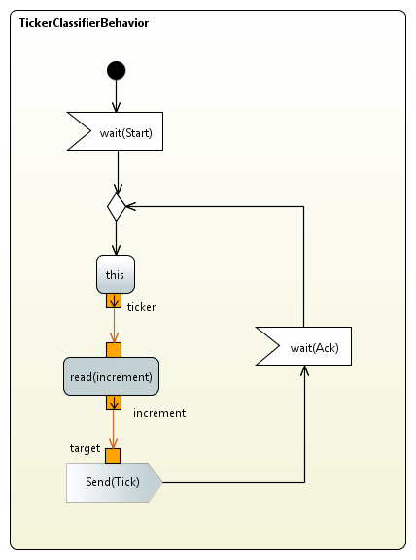 | 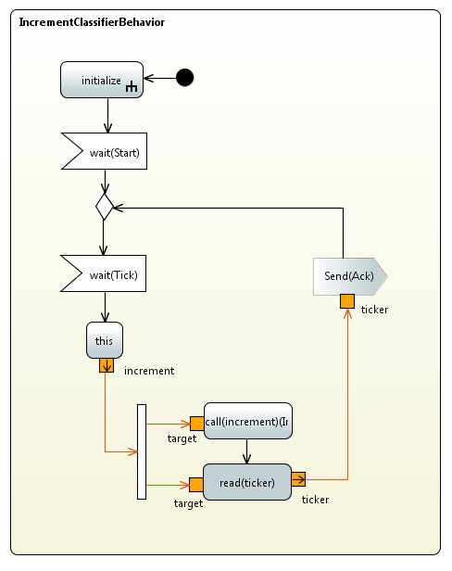

The two activities shown above respectively describes the classifier behaviors of the “Ticker” and “Incrementer” active classes.

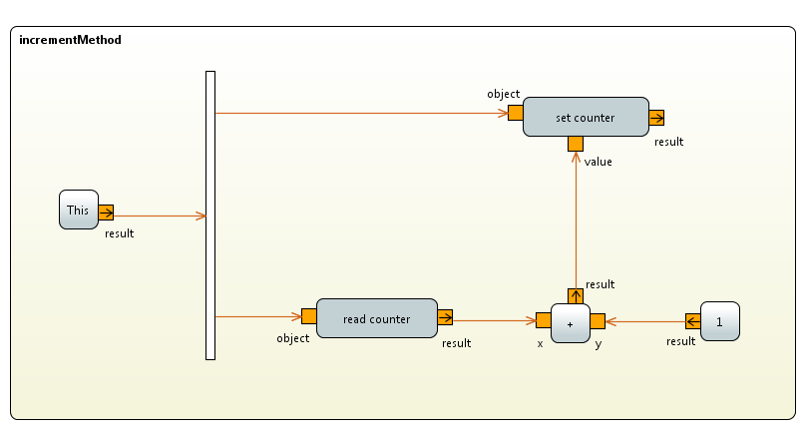
The activity shown above describes the implementation of the increment operation. The “set_counter” action modifies the attribute “counter”, the “result” output-pin is not used and could actually be removed.

Lab 3 – Apply your knowledge about activities in the context of the elevator

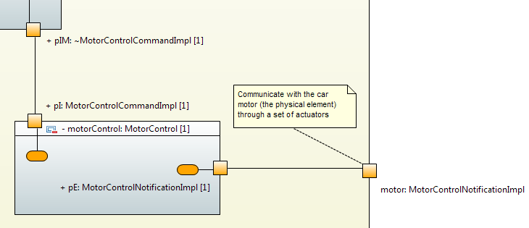

- Send a movement request from the request processor to the motor controller.
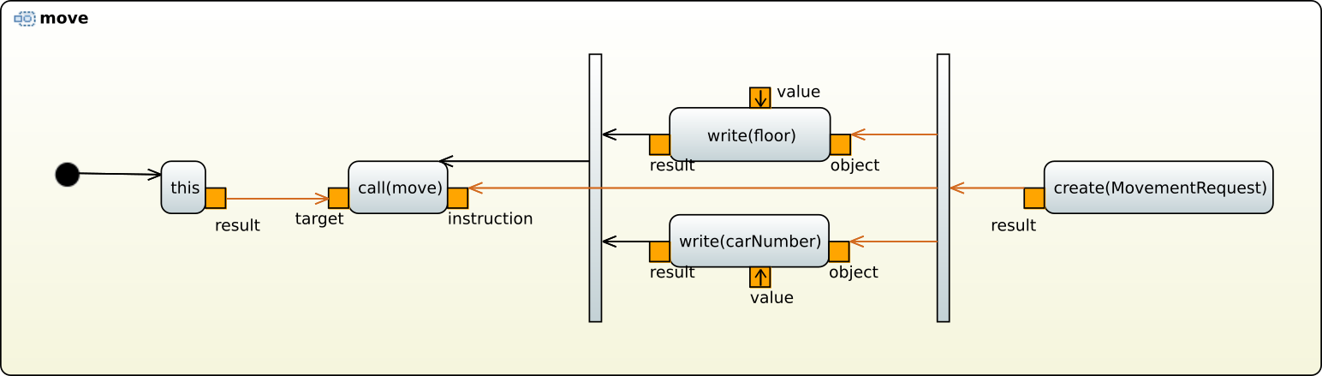

- This can be can be realized with the kind of activity presented above. An object “Movement Request” is created and its attributes are assigned. Note that this part is incomplete on the diagram: the values of write actions must be specified.

- The operation “move” is called through the call operation action “call(move)”. Please note that this operation is owned by the interface “IMotorRequest” and not by implementation “MotorControl”, since the component-based modeling assures a loose coupling of components. The “MovementRequest” is given as a parameter of the operation call. The call is emitted through the port “motorNotificationPort”. The specification of the transmission port can be realized through the property view via the meta-attribute “onPort”.
